Missed infield fly

Definition of Terms of the OBR states that when infield fly is called, the ball remains in play and all runners may advance at their peril. It may occur, therefore, that one or more offensive players take advantage of an infield fly that is not caught to advance to the next base. Such advances, which are generally the result of a fielding error, are noted with the abbreviation “e” (extra base error), followed by the position of the fielder who missed the easy catch, in the square corresponding to the lead runner, who is the one who drew the most benefit from the fielding blunder.
Any other runners advance with the batting order number of the batter, in parentheses.
Example 121: With no out and first and second bases occupied, the shortstop misses an easy infield fly by batter number nine, giving the two runners the opportunity to
advance one base.
The arrival at third base is annotated with the extra base error by the fielder, while the advance to second is annotated with the batting order number (in parentheses) of the batter.
WBSC |  | Traduction dans l’outil de scorage |  | Outil
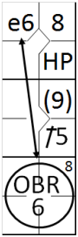 |  | /* Le premier batteur gagne la première base sur un 'hit by pitch' */  action { batter -> HP }  /* Le batteur suivant frappe un hit sur la troisième base, le coureur avance */  action { batter -> 1B5, runner1 -> + }  /* Le frappe un infield fly, mais l'arrêt court commet une erreur, les coureur avance sur l'erreur */  action { batter -> OBR8-6 , runner1 -> (1) , runner2 -> e6 } |  | 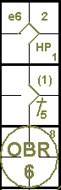

Example 122: Identical conditions and situation as in the previous example.
The only difference is that the shortstop misses the catch because he was dazzled by the sun (or artificial lights), or thrown off by the wind changing the natural trajectory of the ball.
Given that such phenomena prevent the fielder from playing at his best, the advances by both runners are recorded as being made on the hit.
WBSC |  | Traduction dans l’outil de scorage |  | Outil
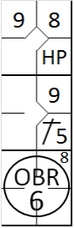 |  | /* Le premier batteur gagne la première base sur un 'hit by pitch' */  action { batter -> HP }  /* Le batteur suivant frappe un hit sur la troisième base, le coureur avance */  action { batter -> 1B5, runner1 -> + }  /* Le frappe un infield fly, le deux coureur avance quand même */  action { batter -> OBR8-6 , runner1 -> + , runner2 -> + } |  | 